ISE 5264: Modeling and Analysis of Semiconductor
Manufacturing (Fall 2024)
Project Phase I (Due: November 5, 2024)
OBJECTIVE
To apply the basics of AutoMod simulation software learned in Assignment 1 to a real-life like wafer fabrication facility.
BACKGROUD INFORMATION
- Introduction to Automated Material Handling Systems (AMHS)
Semiconductor manufacturing is transforming from the processing of 200mm to 300 mm wafers. The dual promises of more chips per wafer and economies of scale have attracted the leading semiconductor manufacturers toward the development of the 300 mm fab. In a 300 mm fab, wafers with diameters of 300 mm (12 inches) are carried in a 25-wafer box, called a front opening unified pod (FOUP), which weights 18 lb (see Figure 1). The FOUP is too heavy to be carried around the factory and handled manually on a repeated basis. Additionally, the use of manual carts in a high volume manufacturing environment will not work efficiently. Thus, the implementation of an automated material handling systems (AMHS) has never been so important in such an environment.
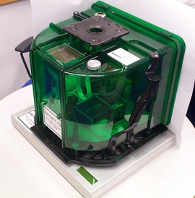
Figure 1 A Front Opening Unified Pod (FOUP)
(Image from http://www.wzgmbh.com/german/products.html)
In general, there are two types of AMHSs that are used in a wafer fab. The first is the inter-bay system, which transports boxes of wafers between process bays. The other is the intra-bay system, which transports boxes of wafers within one process bay.
1.1 The Interbay AMHS
The inter-bay system is build along the main aisle in the fab. It is a one-directional, single-loop overhead system. Vehicles are capable of carrying one lot, i.e., one front opening unified pod (FOUP), at a time.
1.2 The Intra-bay AMHS
The intra-bay transport system is a one-directional Overhead Hoist Transport (OHT) system with one stocker per bay. Each vehicle is capable of carrying one lot at a time. Empty vehicles move continuously until reaching a point where a FOUP is ready to be transferred onto a vehicle.
Vehicles travel their respective loops as they move between stockers or tools. Each loop has a series of stop points at which vehicles can stop to load/unload a lot. Each set of stop points represents an interaction I/O port between a track and a stocker. These points, which are composed of a bypass track, an in-port, and an out-port, are the only places at which a vehicle can stop when a vehicle has to deliver a lot to a stocker or pick up a lot from a stocker, the vehicle transfers from the main track to the bypass track of that stop point without blocking other vehicles. Due to limited size of bypass track at each stop point, only one vehicle at a time can access a stocker. The stocker operations and their interface with them are shown in Figure 2.
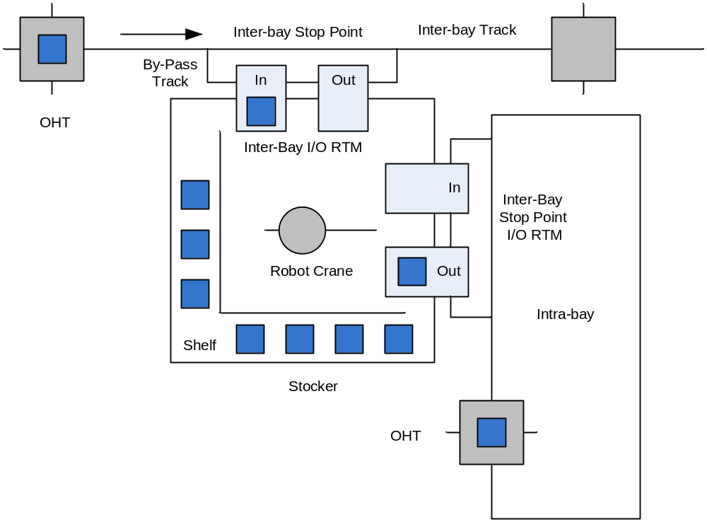
Figure 2 A stocker model and its connection to track systems
Lots wait to be processed either in the buffer of each tool or in the stockers. The stocker of a bay which houses desired tool to process a lot is called the main stocke. Each tool of a bay can have buffer space which consists of either load port or additional/internal buffers.
For continuous wafer processing, each tool should have at least two load ports; one load port for a carrier with wafers in process, and another for a carrier with wafers to be processed. Once the lot in process has been finished, the carrier buffered on the other load port will immediately begin processing. The finished lot will stay in one load port until it is moved by a vehicle. This is illustrated by Figure 3.
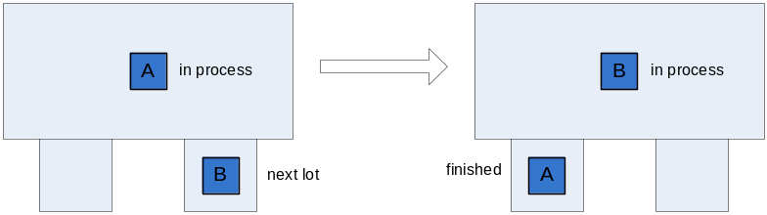
Figure 3 Process sequences of two load ports at a tool
1.3 Segregate Inter-bay/Intra-bay Models
This traditional delivery model utilizes two different vehicles and two sets of tracks, one for the inter-bay system and the other for the intra-bay system. Therefore, inter-bay and intra-bay deliveries are made separately in this model. Vehicles in the inter-bay (or an intra-bay) only perform moves inside the inter-bay (or the corresponding intra-bay) loop.
An intra-bay system is illustrated in Figure 4. A vehicle first picks up Lot 2 from the stocker and unloads it at Machine 1. Then, it deadheads to machine 4 where it picks up Lot 1 and unloads it at the stocker.
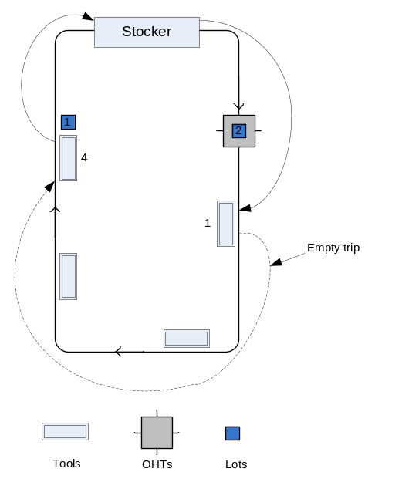
Figure 4 A sketch of the AMHS segregate intra-bay system
Hence, a lot-move from a tool in a bay to another tool in a different bay must include the use of at least three transport systems. As shown in Figure 5, when Lot A is moved from Bay I to Bay VI, it goes through Bay I intra-bay AMHS, inter-bay AMHS and Bay VI intra-bay system.
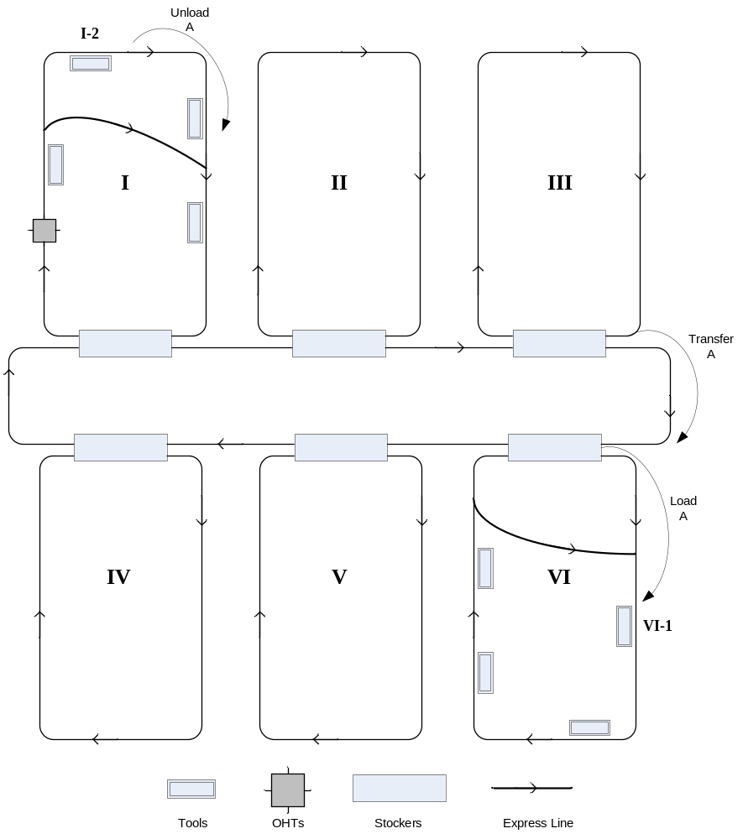|
Figure 5 A segregate inter-bay/intra-bay models
Upon completion of processing at a station, a lot is always moved from the current station to a stocker irrespective of the availability of the next tool or its buffer. This models the worst-case behavior of lot movement in which all tool load ports are always busy. Another advantage is that complicated task-selection algorithms are avoided.
2. Description of the scenario
The Department of Electrical and Computer Engineering (ECE) at Virginia Tech has recently built a research and development fab, the Whittmore Fab. It is built to pilot test the state- of-art Automated Material Handling Systems (AMHS) manufactured by PRI Automation. The process areas and AMHS layout are shown in Figure 6. Note that the tools, stockers and bays are located symmetrically.
The AMHS system includes one inter-bay (the central loop) and four intra-bays (the smaller loops), namely, CMP, Diffusion, Etch and Lithography. There are 18 tools in this fab, 3 tools in CMP Bay, 4 tools in DIFF Bay, 6 tools in ETCH Bay, and 5 tools in LITHO Bay. The tool names, processing times, and buffer capacity are listed in Table 1. AMHS data are included in Table 2.
The followings are the assumptions you can make for this project.
- Each vehicle is capable of carrying one lot at a time.
- All lots are ready at the beginning and have the same priority.
- At the beginning, all lots are stored in the stocker S-CMP and all AGVs are parked at the stockers. After finish all tasks, all AGVs return to their original places.
- Each stocker has unlimited capacity.
- Process times are constant values. There is no variability in processing time. Setup time is negligible.
- On the intra-bay transport systems, empty vehicles move continuously until reaching a point where a FOUP is ready to be transferred onto a vehicle.
- For each move, the path between the origin and destination is known. Thus, there are no alternative routings.
- Pickup/unload time at the stocker or the tool is negligible.
- We also assume AGVs move at the constant speed.
- AGVs only perform tasks in their own bay.
- Tools, vehicles and stockers do not fail and do not need preventive maintenance
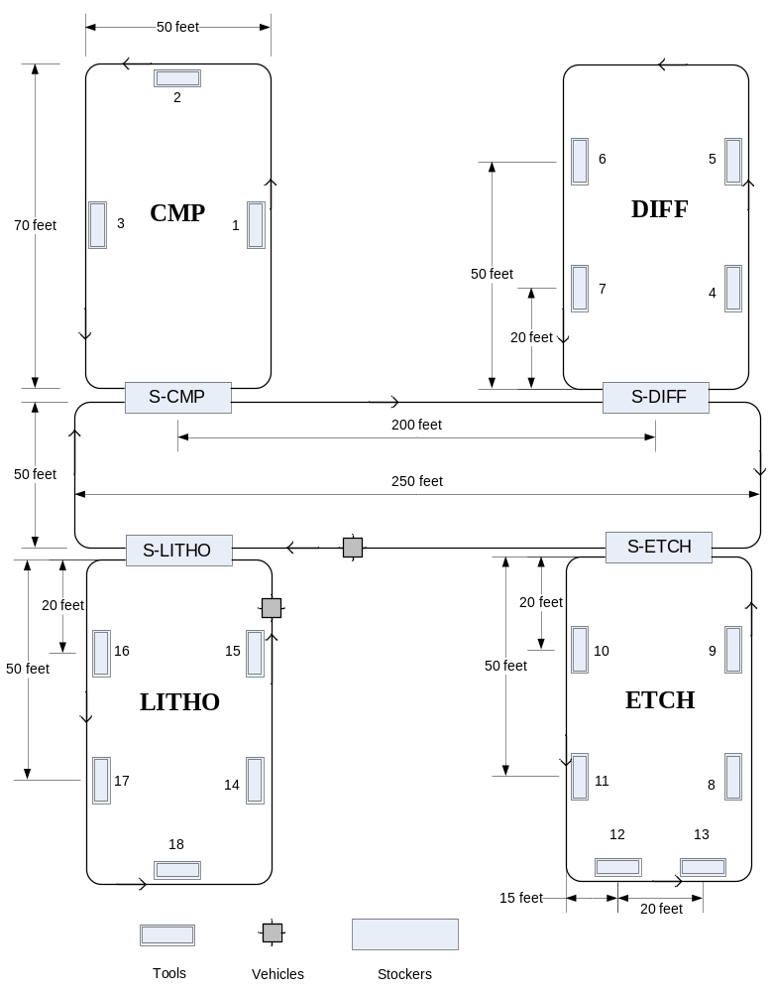
Figure 6 Process areas and AMHS layout

Table 1 Tool names and processing times
Tool index | Tool name | Processing time (hours) | Buffer capacity
1 | SCRBO5CB | 0.1 | 2
2 | SCOP12CB | 0.5 | 2
3 | LAZR01CA | 0.3 | 2
4 | PHDP02DD | 0.2 | 2
5 | NITR02DB | 0.7 | 2
6 | FTTF03DA | 0.05 | 2
7 | PREA02DB | 0.1 | 2
8 | DEPZ03FC | 0.8 | 2
9 | DOPZ04FB | 0.3 | 2
10 | PROF01WB | 0.08 | 2
11 | WSRT07EB | 0.14 | 2
12 | PETZ02FB | 0.9 - | 2
13 | FTSF01FA | 0.09 | 2
14 | CSEM01LH | 0.2 | 2
15 | ILNZ01LG | 1.7 | 4
16 | OVRL01LF | 1.4 | 4
17 | SC0P15LH | 0.5 | 2
18 | DUVC03LH | 1.2 | 4
Table 2 AMHS data
Number of vehicles | Inter-bay | 4
Number of vehicles | CMP Bay | 1
Number of vehicles | DIFF Bay | 1
Number of vehicles | ETCH Bay | 3
Number of vehicles | LITHO Bay | 2
Vehicle travel speed (loaded)(feet/sec) |  | 1.0
Vehicle travel speed (empty) (feet/sec) |  | 1.5
Inter-bay loop | Length (feet) | 250 (horizontal).
 | Width (feet) | 50
Intra-bay loop | Length (feet) | 70 (vertical)
Intra-bay loop | Width (feet) | 50
Stocker capacity (lots) | 200
Tool buffer capacity (lots) | 2

Three types of lots (Type A, B, and C) are processed in this fab. The processes for each lot type are listed in Table 3.

Table 3 Manufacturing Processes for three lot types
Lot type | Manufacturing processes
A | 1-2-4-5-6-9-10-11-13-14-15-18-2
B | l-3-4-5-7-8-9-12-13-14-15-16-17-8-10-11-12-13-14-15-16-17-18-2
C | 1-3-4-5-7-8-9-12-13-2 -3-5- 6-14-15-16-17-2-3-8-10-11-12-13-14-15-16 -17-18-2

3. Questions*
The fab director decides to run 3 lots, Lot 1 (type A), Lot 2 (type B) and Lot 3 (type C). You are asked to build simulation models to answer the following two questions.
3.1 Question 1
Given the information above, create four data files, stn.txt, parts.txt, orders.txt, and route.txt. Run the AutoSched AP model you build and find the makespan (the total time required to process all three lots). Change the process sequence of the three lots (you need to try all possible sequences). Are the makespans the same for different sequences?
Hint: Lot movement between tools can be considered as a process in the route file. The processing time is estimated to be the theoretical vehicle travel time*1.5 due to possible waiting time.
3.2 Question 2
Given the information above, build the AutoMod model for this fab. Run the model and find the average cycle time (the time each lot spends in processing or in the system) for the three lots. Change the process sequence of the three lots (you need to try all possible sequences). Are the average cycle times the same for different sequences?
Hint: The time a lot will stay at a tool can be estimated by its corresponding processing time at the tool.
4. Procedures
You can work in teams of two. Please submit a brief report summarizing your work and answers to the above questions. This report should also include your simulation model on a CD. Alternately, you may submit your simulation model via the digital drop box.
________________________________________________________
*In case access to AutoSched AP does not become available, each team will work only on Question 2.

